

HOUSE PRICE PREDICTION SYSTEM

MADE BY – SHAURYA PAREEK
FACULTY – MS. MONICA SANKAT
REG. NO. – 25BHI10041
COURSE – B.TECH
SLOT – C11+C12+C13

1. Introduction
In today’s world, data plays an important role in decision-making. In the real estate sector, predicting house prices accurately is very useful for both buyers and sellers. This project focuses on building a simple system that can estimate house prices using machine learning techniques.
The project also includes a basic login and signup system so that users can securely access the application. This makes the project closer to a real-world system instead of just a simple model.

2. Objective
The main objectives of this project are:
- To build a machine learning model that predicts house prices
- To understand how Linear Regression works
- To create a command-line based application
- To implement a basic login and signup system
- To store and display prediction history

3. Problem Statement
Estimating house prices manually can be difficult and sometimes inaccurate. Different factors like area, number of rooms, and facilities affect the price.
This project aims to solve this problem by using a machine learning model that can predict prices based on input values provided by the user

4. Methodology
The project is implemented step by step as follows:
First, a dataset is created containing house details such as area, number of bedrooms, bathrooms, and their corresponding prices.
The dataset is then loaded using Pandas. The input features (area, bedrooms, bathrooms) are separated from the output (price).
Next, the data is divided into training and testing sets using train-test split. A Linear Regression model is then trained using the training data.
After training, the model is tested using test data and its performance is measured using the R² score.
The application also includes a menu-driven interface where the user can:
- Predict house prices
- View dataset information
- Check model accuracy
- View and clear prediction history
Additionally, a login and signup system is implemented using file handling.

5. Tools and Technologies Used
- Python
- Pandas library
- Scikit-learn library
- Visual Studio Code
Concepts used:
- Machine Learning
- Linear Regression
- File Handling
- Command Line Interface

6. Features of the System
- User login and signup functionality
- House price prediction based on input
- Model accuracy display using R² score
- Storage of prediction history
- Display of last few predictions in readable format
- Option to clear prediction history
- Dataset information and summary
- Categorization of prices into Low, Medium, and Luxury

7. System Design
The system works in the following flow:
- User signs up or logs in
- Dataset is loaded
- Model is trained
- User selects options from menu
- System performs prediction or other operations
8. Algorithm Used
Linear Regression is used in this project.
It is a simple and widely used machine learning algorithm for predicting continuous values. It finds a relationship between input variables and output.
In this project, it predicts house prices based on:
- Area
- Bedrooms
- Bathrooms
9. Input and Output
Input:
- Area of house
- Number of bedrooms
- Number of bathrooms
Output:
- Predicted house price
- Category of house (Low / Medium / Luxury)

10. Sample Result
Example:
Input:
Area: 2000
Bedrooms: 3
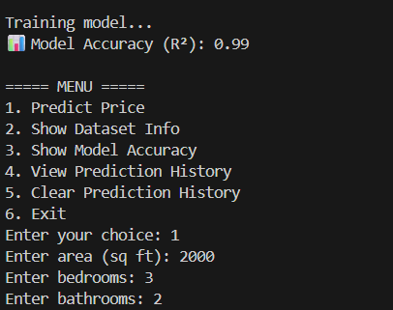
Bathrooms: 2

Output:
Estimated Price: ₹5000000
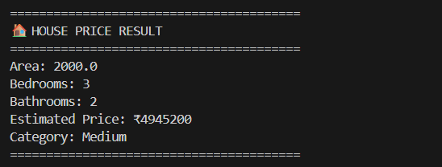
Category: Medium

11. Advantages
- Easy to use interface
- Fast predictions
- Simple implementation
- Includes login system
- Stores user prediction history

12. Limitations
- Dataset is small
- Only basic features are used
- No graphical interface
- Passwords are stored in simple format

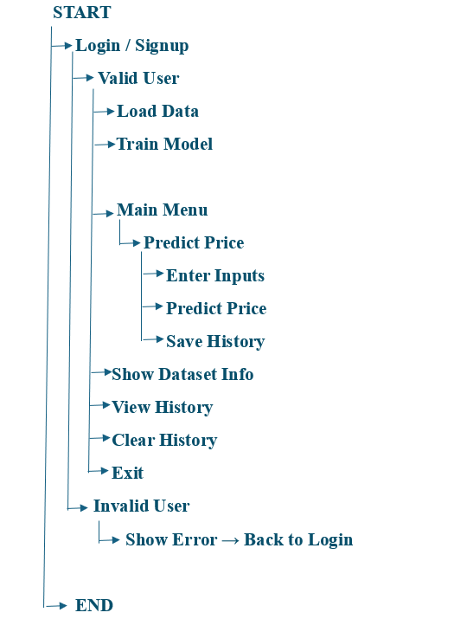
DIAGRAM OF THE MODEL

13. Future Scope
- Add more features like location, parking, etc.
- Use a larger real dataset
- Create a graphical or web interface
- Improve security using password encryption
- Deploy the system online

14. Conclusion
This project shows how machine learning can be applied to solve real-life problems like house price prediction. It also demonstrates the use of Python, data handling, and model training in a practical way.
The addition of login and history features makes it more interactive and useful.

15. References
- Python Documentation
- Scikit-learn Documentation
- Pandas Documentation

